1. 
2. Agenda:
   1. In the following lessons, we will learn how to create Spring Boot Application that acts as Kafka Consumer.
3. 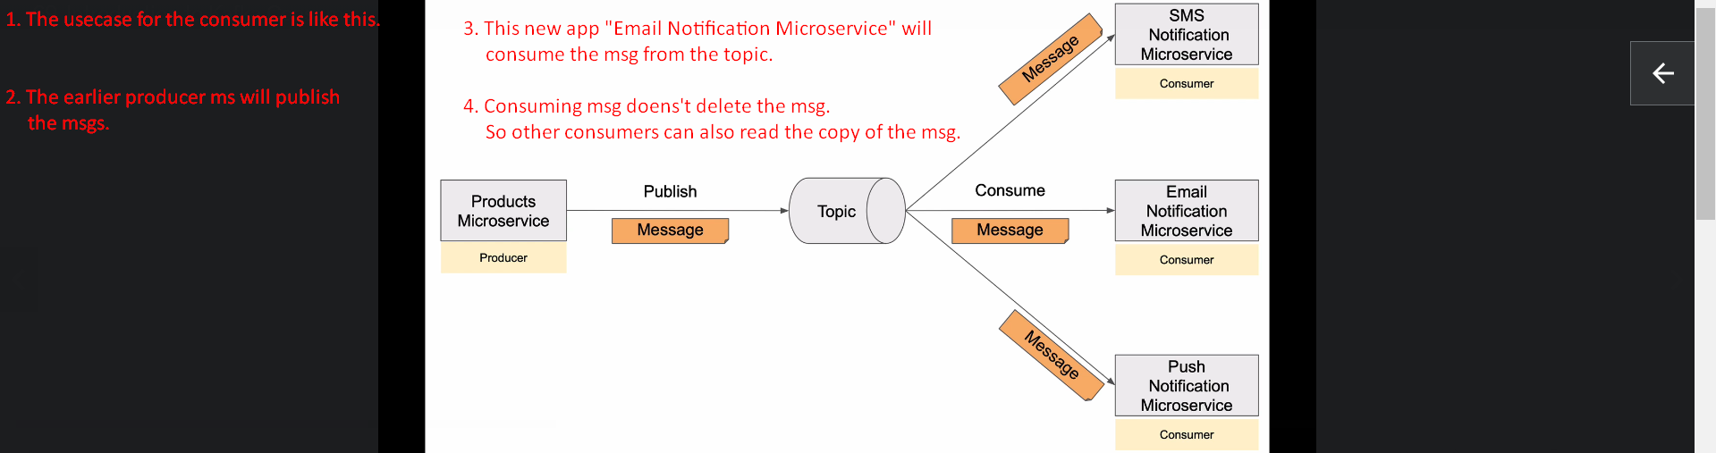
4. When we start consumer app, it starts pulling msgs at regular time interval which can be configured.
5. A consumer starts reading msgs in parallel and so there is no order guarantee which msgs from which partitions will be read in which order but it reads msgs in order within a single partition.
6. 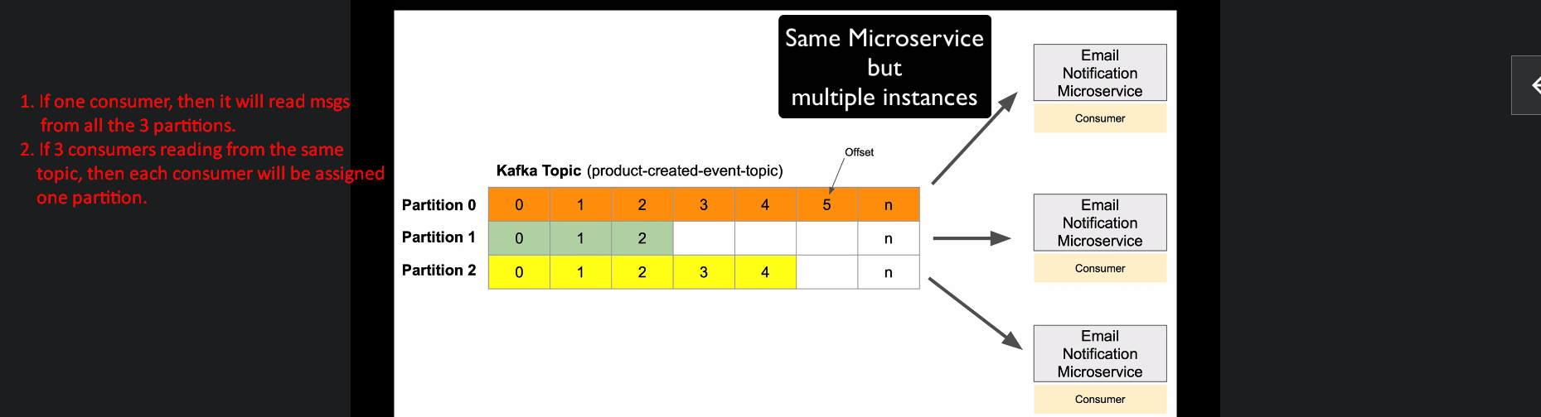  
   We need to start all the 3 consumers in the same group so that they can be assigned a dedicated partition thus not reading the same msg more than once.
7. The msgs persist in topic for 7days = 168hours.  
   We can change the configuration.